Line Segment in Solid Geometry

Definition
# Source: AI Source: Provided by: [Data Path: Persons Table -> ID Column: 1, Name_En Column: Motasem Essam] -> From: [ChatGPT] on [7/25/2026]
A Line Segment in Solid Geometry is a straight part of a line bounded by two distinct endpoints. It has a finite length and lies within three-dimensional space.
A line segment may connect two vertices of a solid, form an edge of a polyhedron, or connect two points located anywhere in space.

Simple Definition
# Source: AI Source: Provided by: [Data Path: Persons Table -> ID Column: 1, Name_En Column: Motasem Essam] -> From: [ChatGPT] on [7/25/2026]
A line segment is a straight path between two endpoints, with a fixed and measurable length.
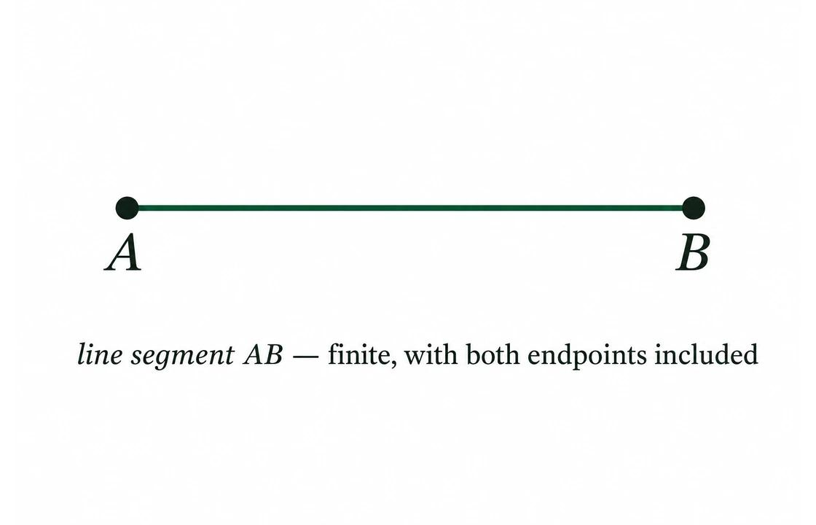
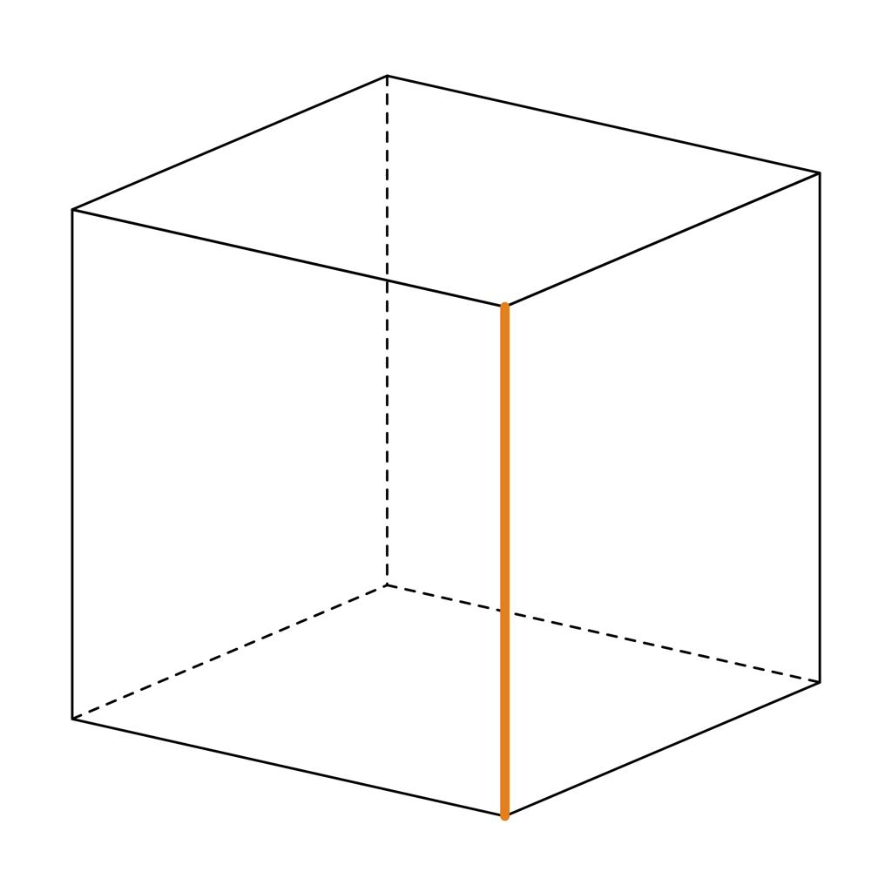
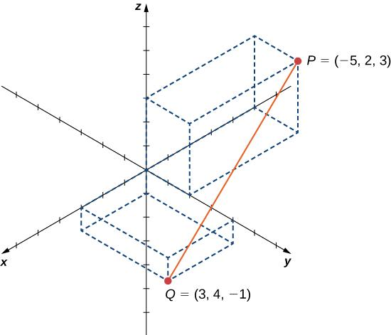

Fundamental Properties
# Source: AI Source: Provided by: [Data Path: Persons Table -> ID Column: 1, Name_En Column: Motasem Essam] -> From: [ChatGPT] on [7/25/2026]
- Finite Length: A line segment has a fixed, measurable length.
- Two Endpoints: It begins and ends at two distinct points.
- Straightness: It follows a straight path without curvature.
- One-Dimensional: It has length but no width or thickness.
- Points Between Endpoints: Every point between its endpoints belongs to the segment.
- Shortest Path: In Euclidean geometry, the line segment is the shortest path between its two endpoints.

Types of Line Segments in Solid Geometry
# Source: AI Source: Provided by: [Data Path: Persons Table -> ID Column: 1, Name_En Column: Motasem Essam] -> From: [ChatGPT] on [7/25/2026]
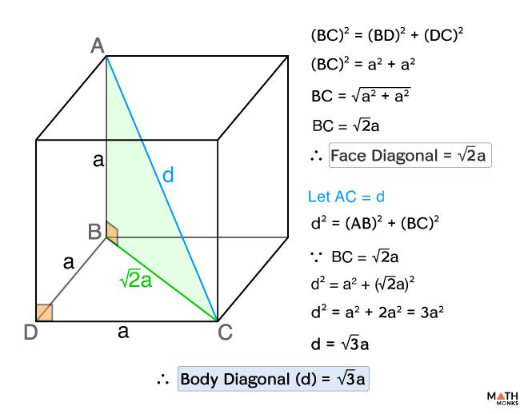
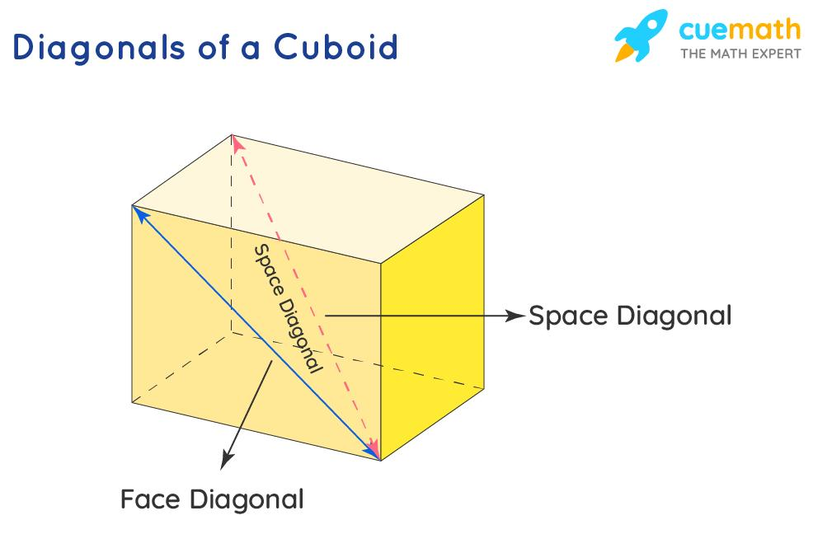
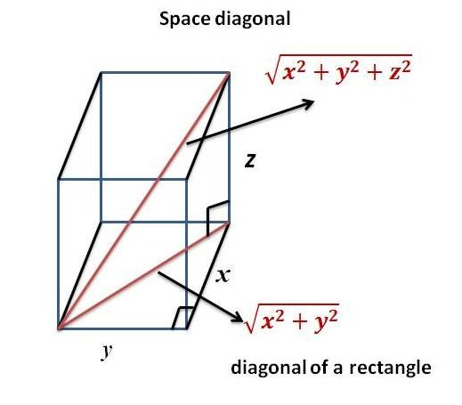

1. Edge of a Solid
# Source: AI Source: Provided by: [Data Path: Persons Table -> ID Column: 1, Name_En Column: Motasem Essam] -> From: [ChatGPT] on [7/25/2026]
An edge is a line segment forming part of the boundary of a polyhedron, where two faces meet.
Example: Each cube has 12 edges, each represented by a line segment.

2. Segment Joining Two Points in Space
# Source: AI Source: Provided by: [Data Path: Persons Table -> ID Column: 1, Name_En Column: Motasem Essam] -> From: [ChatGPT] on [7/25/2026]
A line segment may connect any two distinct points in three-dimensional space, whether or not those points are vertices of the same solid.

3. Diagonal of a Face
# Source: AI Source: Provided by: [Data Path: Persons Table -> ID Column: 1, Name_En Column: Motasem Essam] -> From: [ChatGPT] on [7/25/2026]
A face diagonal is a line segment connecting two non-adjacent vertices of the same face.
Example: A square face of a cube has two diagonals.

4. Space Diagonal
# Source: AI Source: Provided by: [Data Path: Persons Table -> ID Column: 1, Name_En Column: Motasem Essam] -> From: [ChatGPT] on [7/25/2026]
A space diagonal is a line segment joining two vertices of a solid that do not lie on the same face.
Example: A cube has four space diagonals.

5. Midpoint of a Segment
# Source: AI Source: Provided by: [Data Path: Persons Table -> ID Column: 1, Name_En Column: Motasem Essam] -> From: [ChatGPT] on [7/25/2026]
The midpoint is the point exactly halfway between the endpoints of a line segment. It divides the segment into two equal lengths.

Representation and Notation
# Source: AI Source: Provided by: [Data Path: Persons Table -> ID Column: 1, Name_En Column: Motasem Essam] -> From: [ChatGPT] on [7/25/2026]
A line segment with endpoints $A$ and $B$ is written as
$$\overline{AB}$$
Its length is written as $AB$ or $\left|\overline{AB}\right|$.
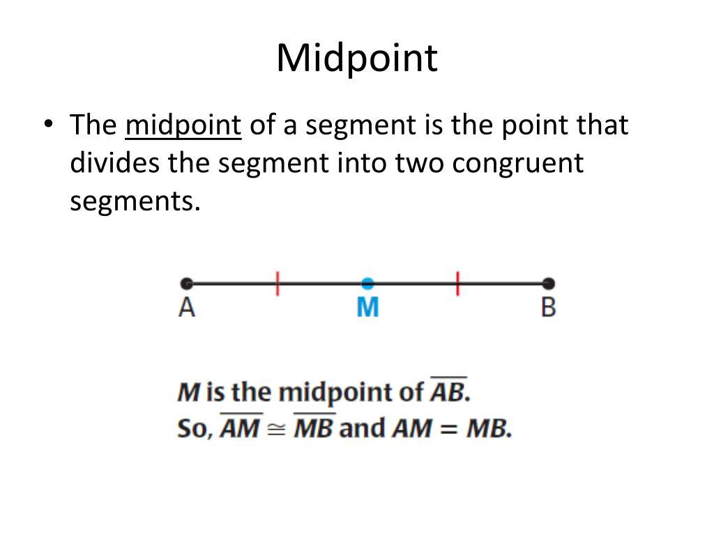
If $M$ is the midpoint of $\overline{AB}$, then
$$AM=MB=\frac{AB}{2}$$
For example, if $AB=10\text{ cm}$, then
$$AM=MB=5\text{ cm}$$

Length of a Line Segment in Three-Dimensional Space
# Source: AI Source: Provided by: [Data Path: Persons Table -> ID Column: 1, Name_En Column: Motasem Essam] -> From: [ChatGPT] on [7/25/2026]
The distance between two endpoints can be calculated using their three-dimensional coordinates.
Let
$$A=\left(x_{1},y_{1},z_{1}\right), B=\left(x_{2},y_{2},z_{2}\right)$$
The length of the segment is
$$\boxed{AB=\sqrt{{\left(x_{2}-x_{1}\right)}^{2}+{\left(y_{2}-y_{1}\right)}^{2}+{\left(z_{2}-z_{1}\right)}^{2}}}$$
Example
Suppose
$$A=\left(1,2,3\right), B=\left(4,6,3\right)$$
Then
$$\begin{aligned}AB&=\sqrt{{\left(4-1\right)}^{2}+{\left(6-2\right)}^{2}+{\left(3-3\right)}^{2}} \\ &=\sqrt{9+16+0} \\ &=\sqrt{25} \\ &=\boxed{5\text{ units}}\end{aligned}$$

Important Formulas for Solids
# Source: AI Source: Provided by: [Data Path: Persons Table -> ID Column: 1, Name_En Column: Motasem Essam] -> From: [ChatGPT] on [7/25/2026]
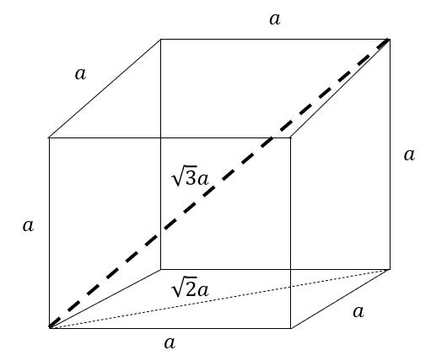
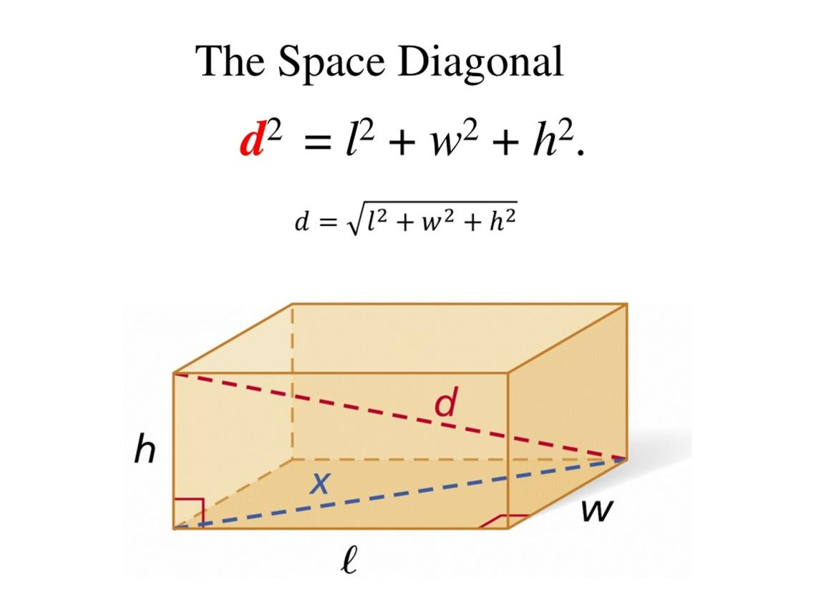
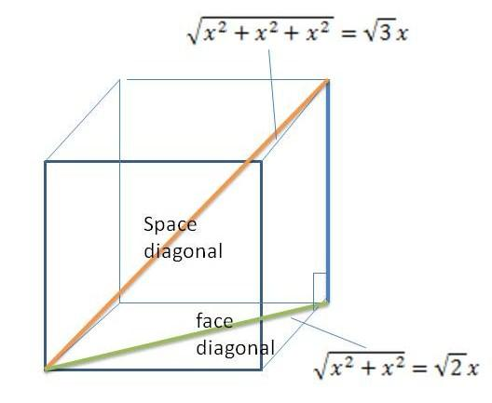

1 Diagonal of a Square Face
# Source: AI Source: Provided by: [Data Path: Persons Table -> ID Column: 1, Name_En Column: Motasem Essam] -> From: [ChatGPT] on [7/25/2026]
For a cube with side length $a$, the diagonal of each square face is
$$d_{f}=\sqrt{a^{2}+a^{2}}=\boxed{a\sqrt{2}}$$

2 Space Diagonal of a Cube
# Source: AI Source: Provided by: [Data Path: Persons Table -> ID Column: 1, Name_En Column: Motasem Essam] -> From: [ChatGPT] on [7/25/2026]
The space diagonal of a cube is
$$d_{s}=\sqrt{a^{2}+a^{2}+a^{2}}=\boxed{a\sqrt{3}}$$

3 Space Diagonal of a Cuboid
# Source: AI Source: Provided by: [Data Path: Persons Table -> ID Column: 1, Name_En Column: Motasem Essam] -> From: [ChatGPT] on [7/25/2026]
For a cuboid with length $l$, width $w$, and height $h$,
$$\boxed{d=\sqrt{l^{2}+w^{2}+h^{2}}}$$
Example
A cube has side length $4\text{ cm}$.
- Edge length: $4\text{ cm}$
- Face diagonal: $4\sqrt{2}\text{ cm}$
- Space diagonal: $4\sqrt{3}\text{ cm}$
These formulas follow from the Pythagorean theorem applied in two and three dimensions.

Constructing Line Segment in Solid Geometry

Types of Instrument-Based Construction Tools
# Source: AI Source: Provided by: [Data Path: Persons Table -> ID Column: 1, Name_En Column: Motasem Essam] -> From: [ChatGPT] on [7/25/2026]
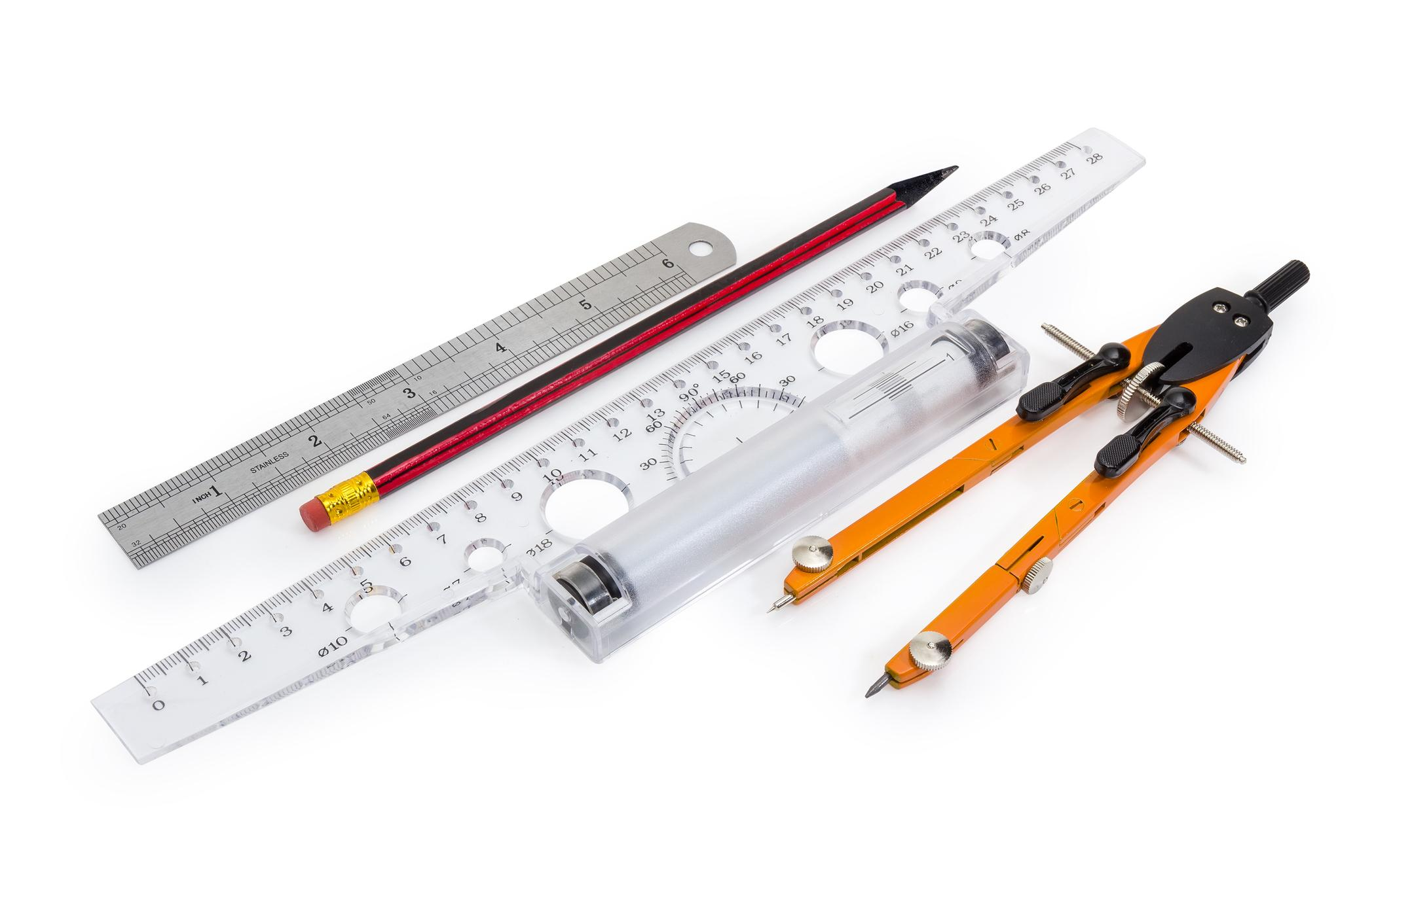

Ruler
# Source: AI Source: Provided by: [Data Path: Persons Table -> ID Column: 1, Name_En Column: Motasem Essam] -> From: [ChatGPT] on [7/25/2026]
Used to construct and measure line segments of specified lengths.
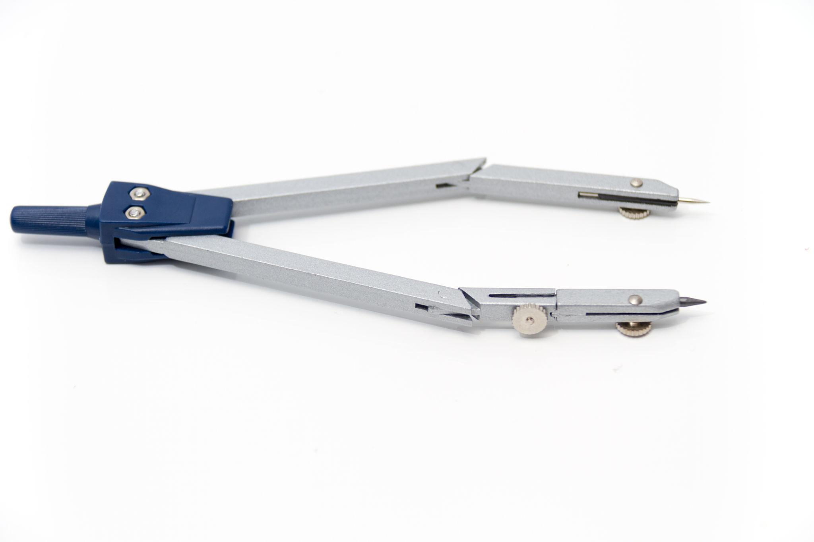

Straightedge
# Source: AI Source: Provided by: [Data Path: Persons Table -> ID Column: 1, Name_En Column: Motasem Essam] -> From: [ChatGPT] on [7/25/2026]
Used to draw straight segments between given endpoints without necessarily measuring their lengths.
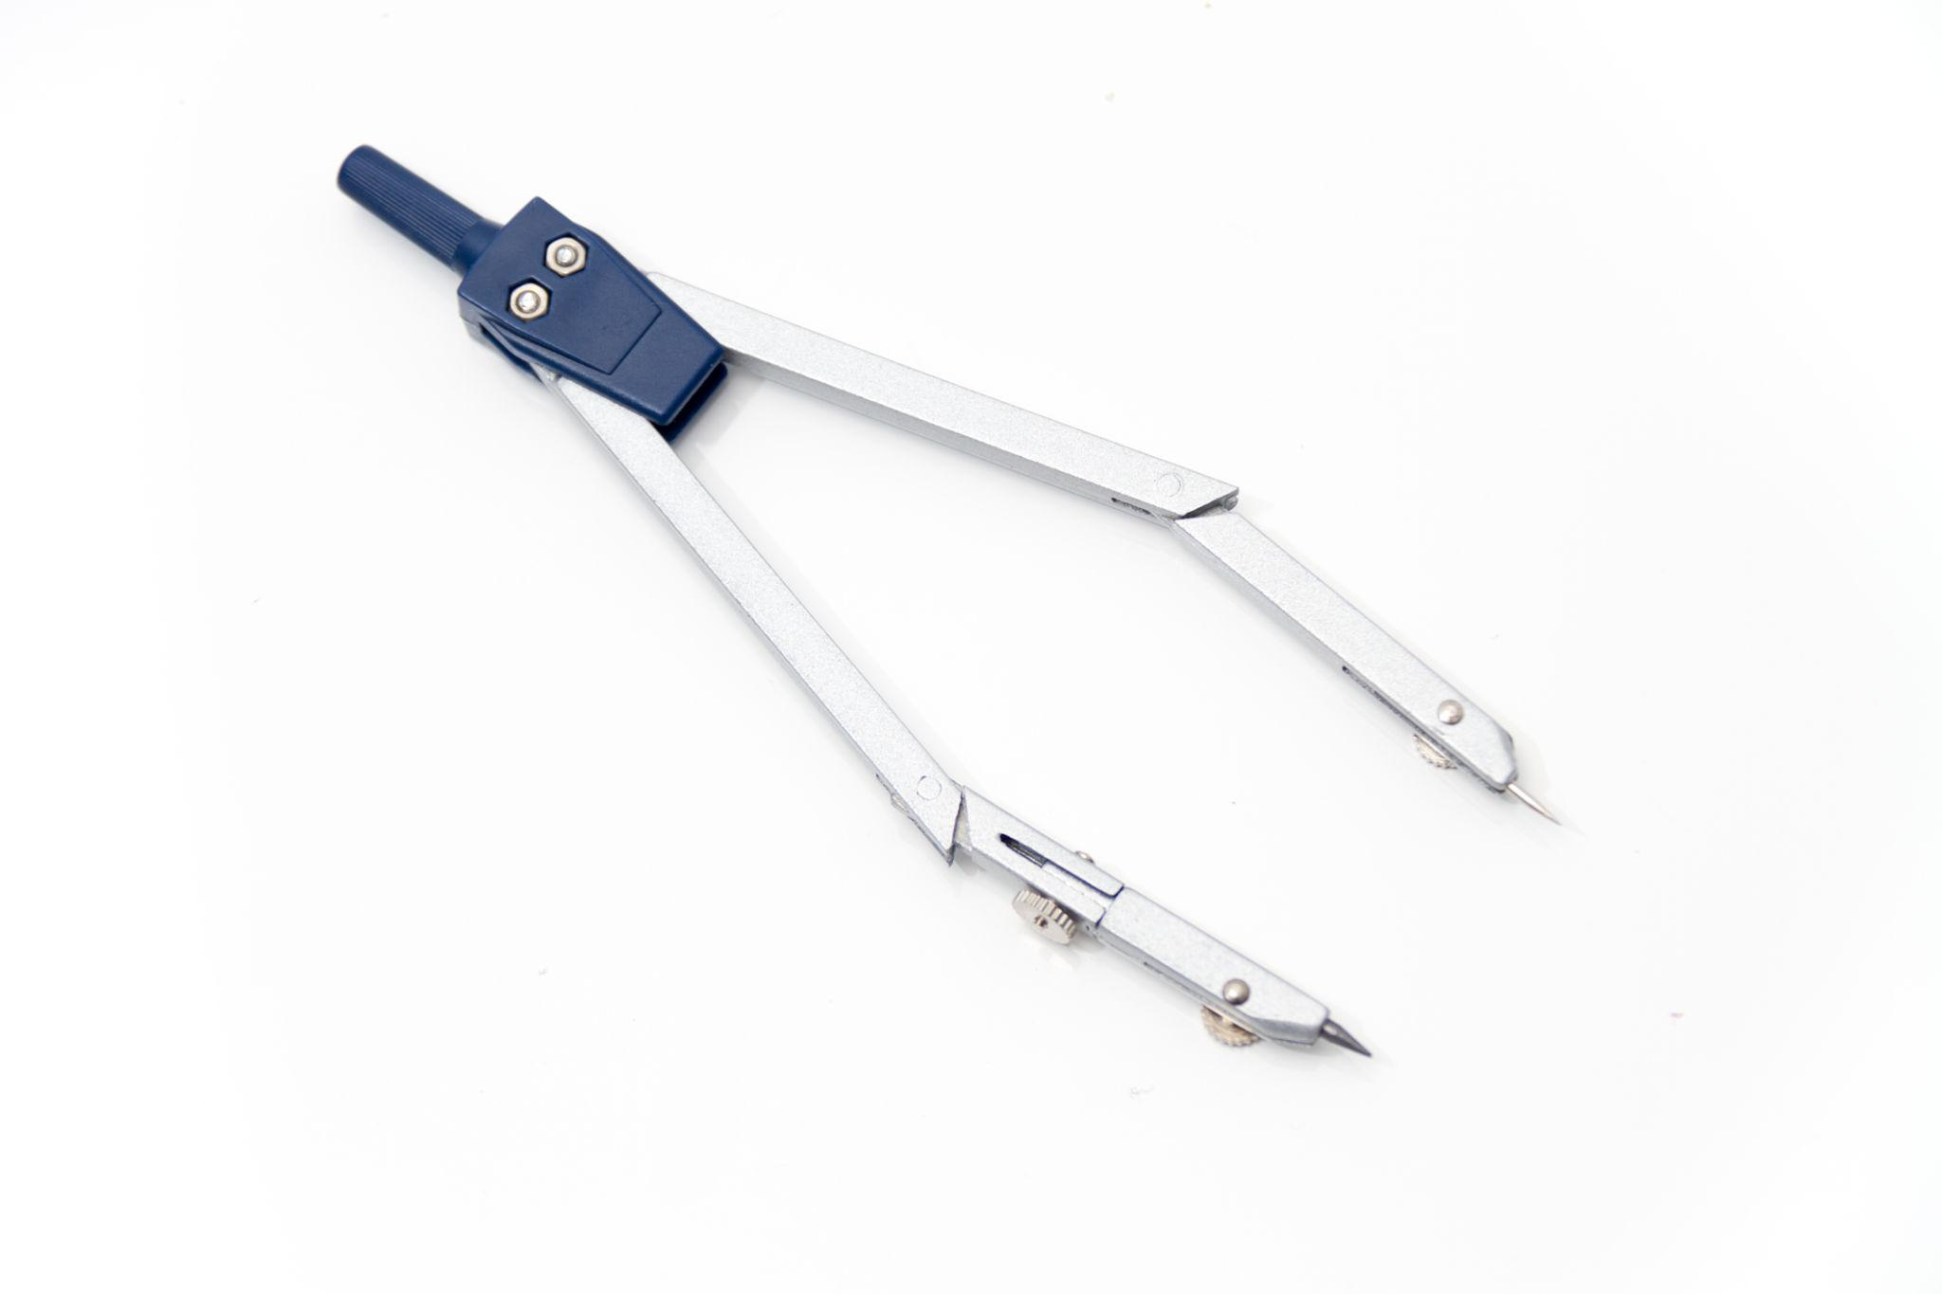

Compass
# Source: AI Source: Provided by: [Data Path: Persons Table -> ID Column: 1, Name_En Column: Motasem Essam] -> From: [ChatGPT] on [7/25/2026]
Used to transfer lengths, construct equal segments, and locate points at specified distances.
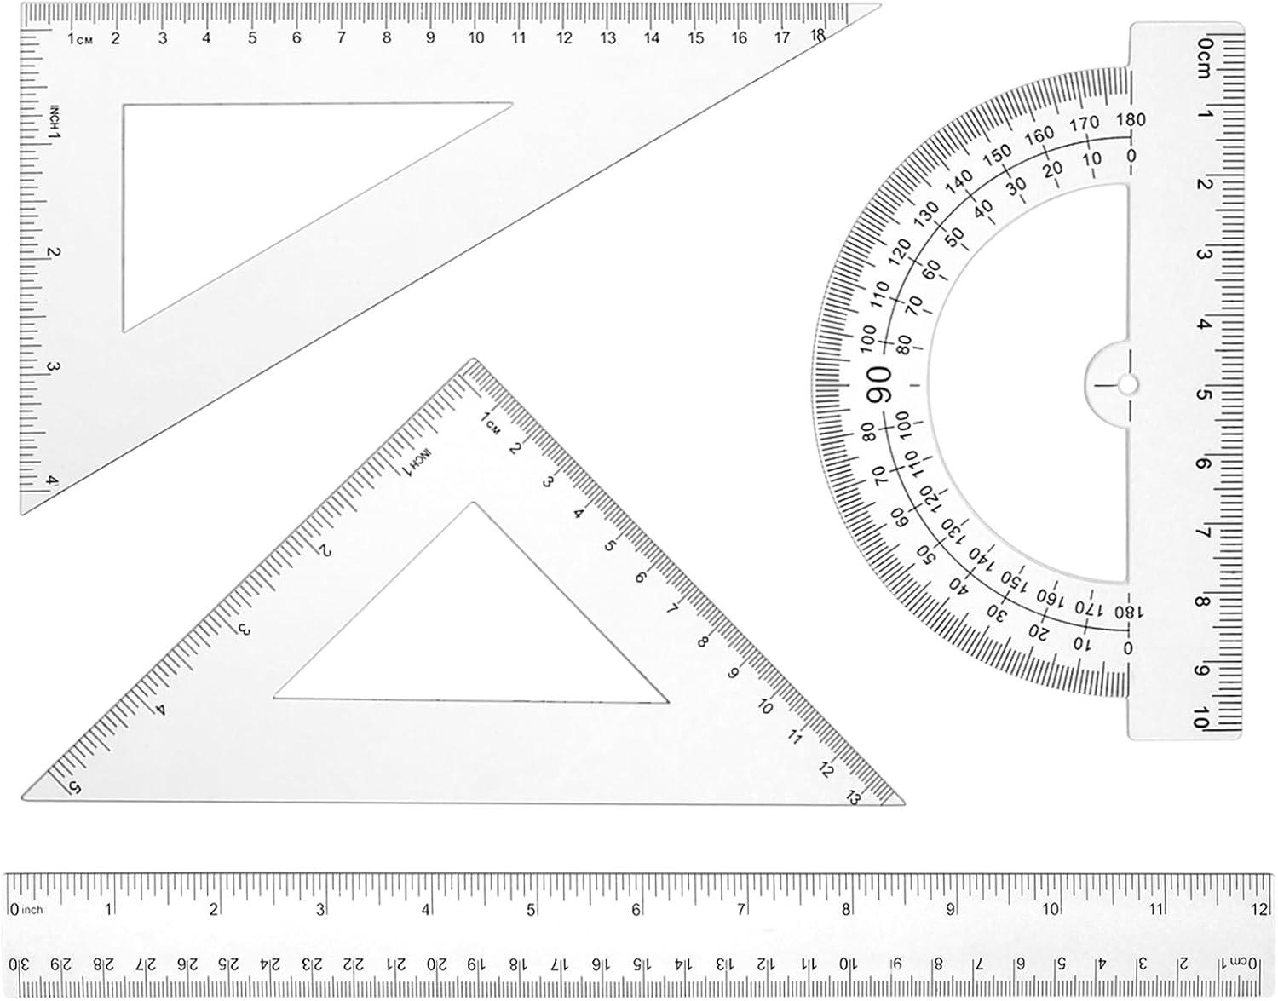

Set Square
# Source: AI Source: Provided by: [Data Path: Persons Table -> ID Column: 1, Name_En Column: Motasem Essam] -> From: [ChatGPT] on [7/25/2026]
Used to construct perpendicular and parallel line segments.
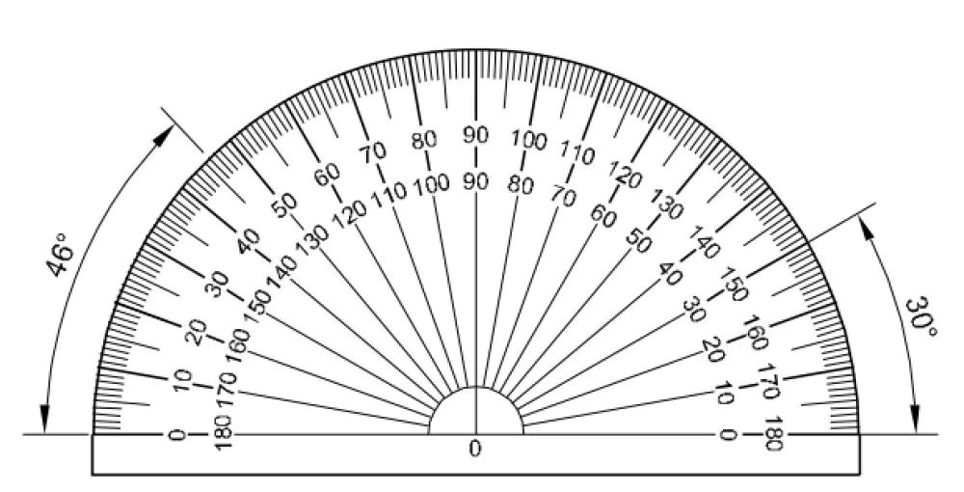

Protractor
# Source: AI Source: Provided by: [Data Path: Persons Table -> ID Column: 1, Name_En Column: Motasem Essam] -> From: [ChatGPT] on [7/25/2026]
Used to construct and measure angles that determine the inclination of line segments.
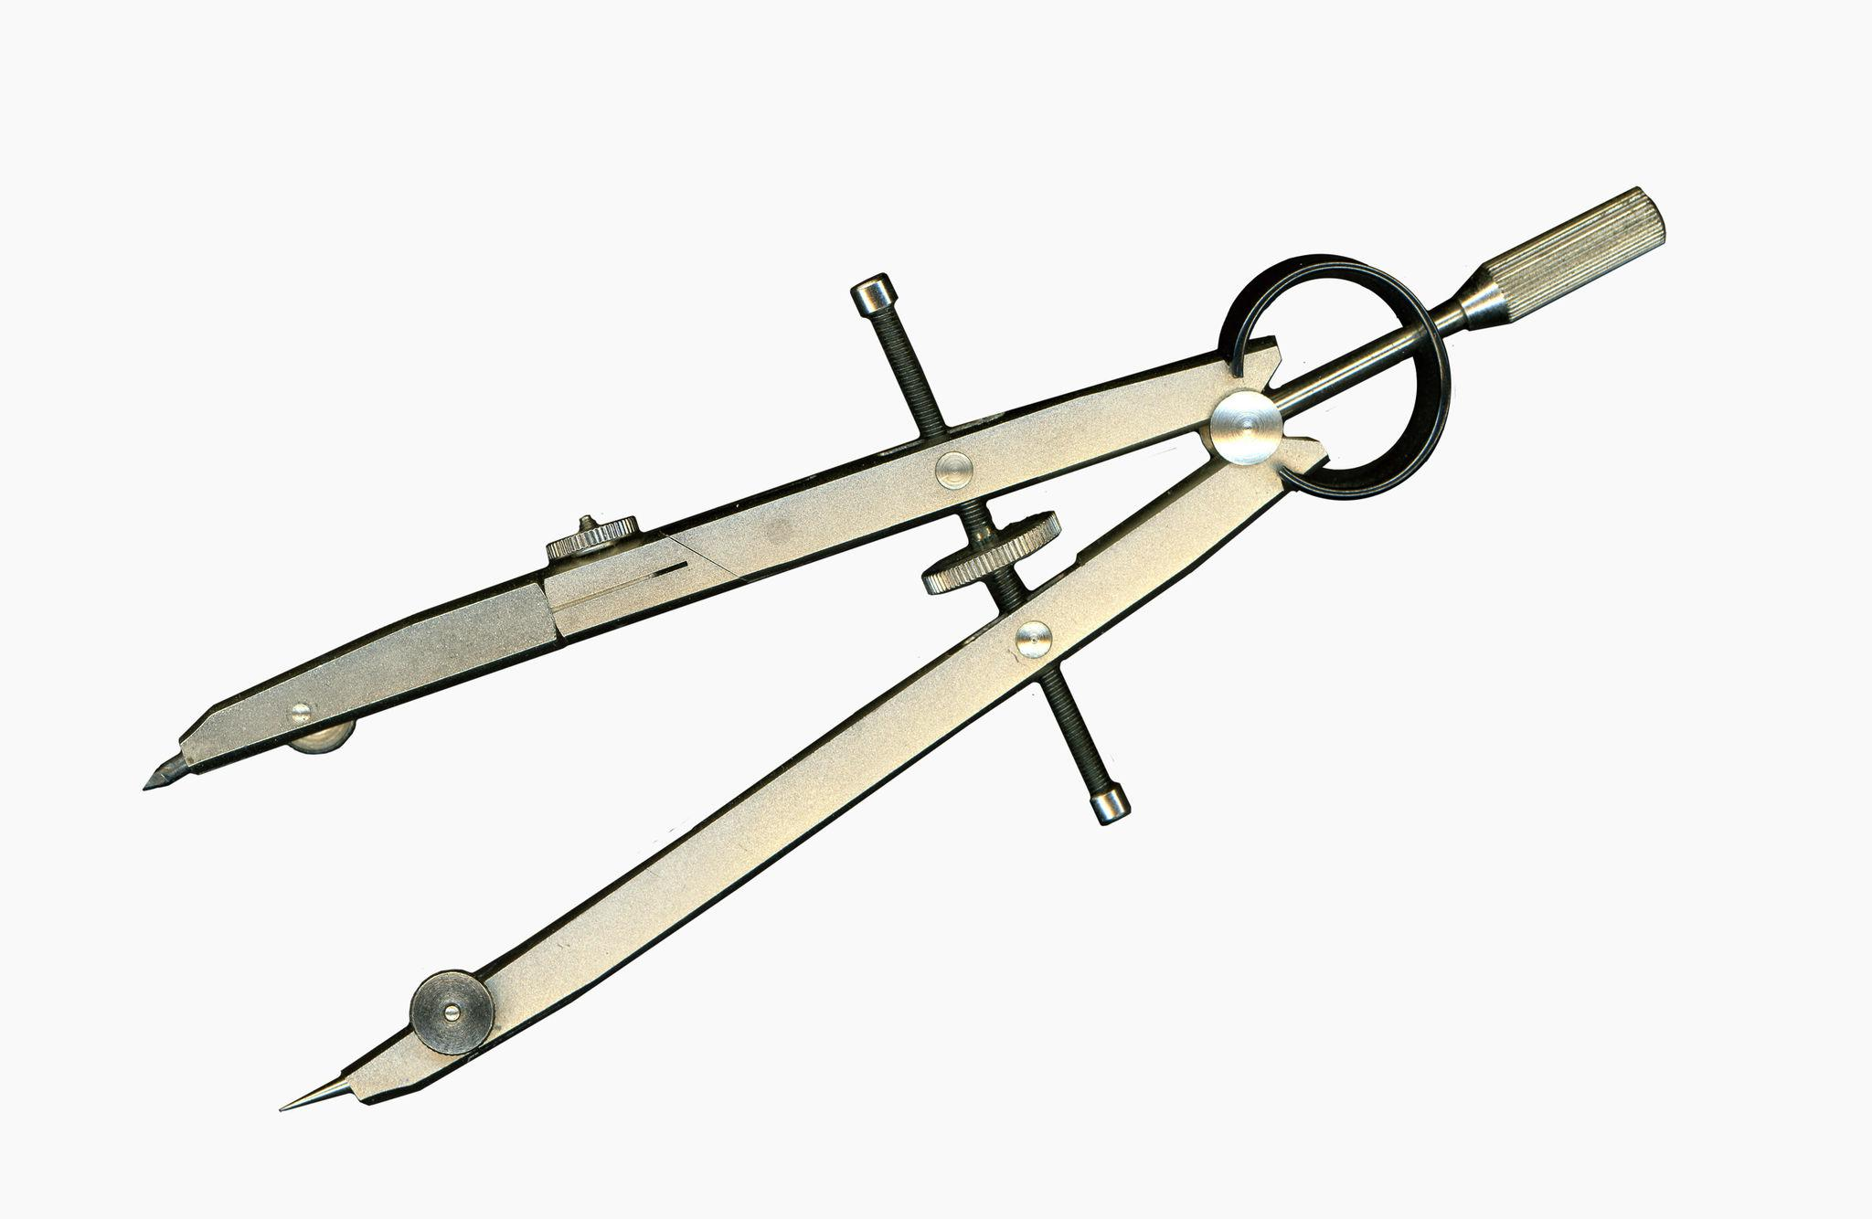

Dividers
# Source: AI Source: Provided by: [Data Path: Persons Table -> ID Column: 1, Name_En Column: Motasem Essam] -> From: [ChatGPT] on [7/25/2026]
Used to transfer and compare segment lengths between different geometric locations.

Fundamental Instrument-Based Construction Procedures

Constructing a Line Segment Between Two Points
# Source: AI Source: Provided by: [Data Path: Persons Table -> ID Column: 1, Name_En Column: Motasem Essam] -> From: [ChatGPT] on [7/25/2026]
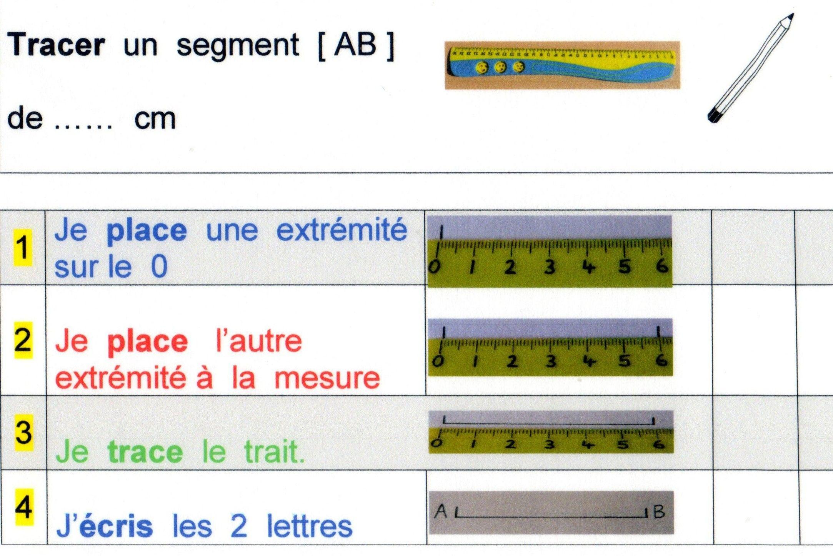
Procedure:
- Mark the first endpoint $A$.
- Mark the second endpoint $B$.
- Place a straightedge through both points.
- Draw a straight line connecting them.
- Identify the finite portion between $A$ and $B$ as the required line segment.

Constructing a Given-Length Line Segment
# Source: AI Source: Provided by: [Data Path: Persons Table -> ID Column: 1, Name_En Column: Motasem Essam] -> From: [ChatGPT] on [7/25/2026]
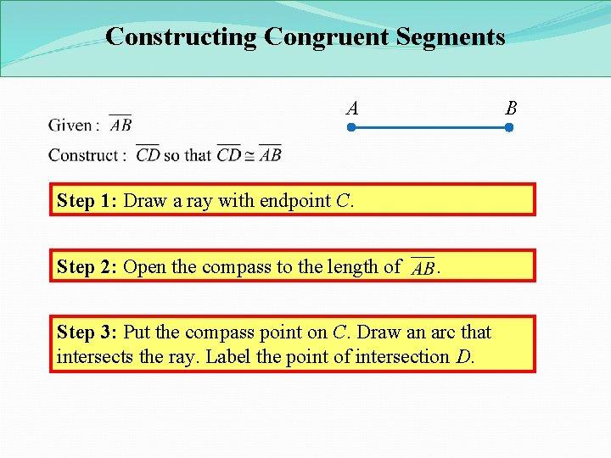
Procedure:
- Mark the starting point $A$.
- Set the required length using a ruler or compass.
- Position the ruler or compass from $A$.
- Mark the endpoint $B$ at the specified distance.
- Connect the two endpoints using a straightedge.

Constructing a Congruent Line Segment
# Source: AI Source: Provided by: [Data Path: Persons Table -> ID Column: 1, Name_En Column: Motasem Essam] -> From: [ChatGPT] on [7/25/2026]
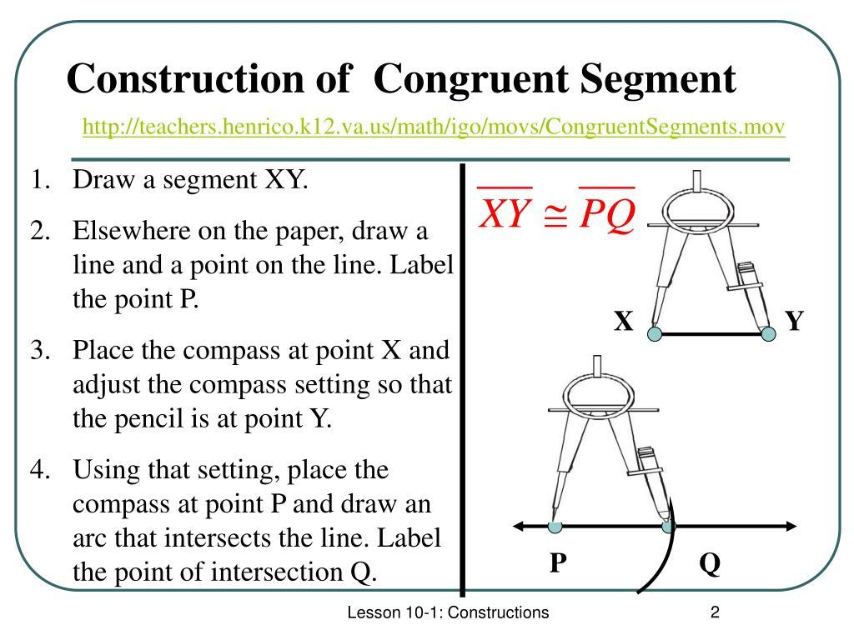
Procedure:
- Identify the original segment $AB$.
- Open the compass to the length $AB$.
- Mark a new starting point $C$.
- Draw an arc centered at $C$ using the same compass opening.
- Select the required endpoint $D$ on the arc.
- Connect $C$ and $D$.
The resulting segment satisfies:
$$AB=CD$$

Constructing a Midpoint
# Source: AI Source: Provided by: [Data Path: Persons Table -> ID Column: 1, Name_En Column: Motasem Essam] -> From: [ChatGPT] on [7/25/2026]
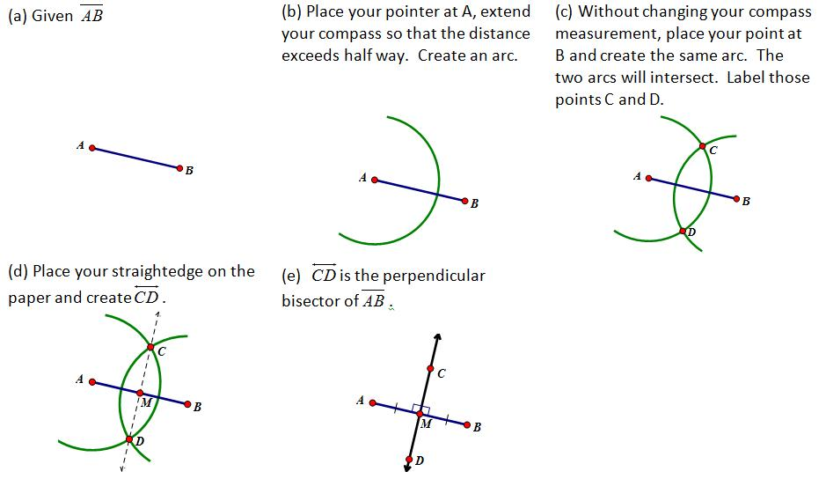
Procedure:
- Draw the given segment $AB$.
- Set the compass radius greater than half of $AB$.
- Draw arcs centered at $A$ and $B$, above and below the segment.
- Connect the arc intersection points.
- Mark the intersection with $AB$ as midpoint $M$.
The midpoint satisfies:
$$AM=MB=\frac{AB}{2}$$

Constructing a Divided Line Segment
# Source: AI Source: Provided by: [Data Path: Persons Table -> ID Column: 1, Name_En Column: Motasem Essam] -> From: [ChatGPT] on [7/25/2026]
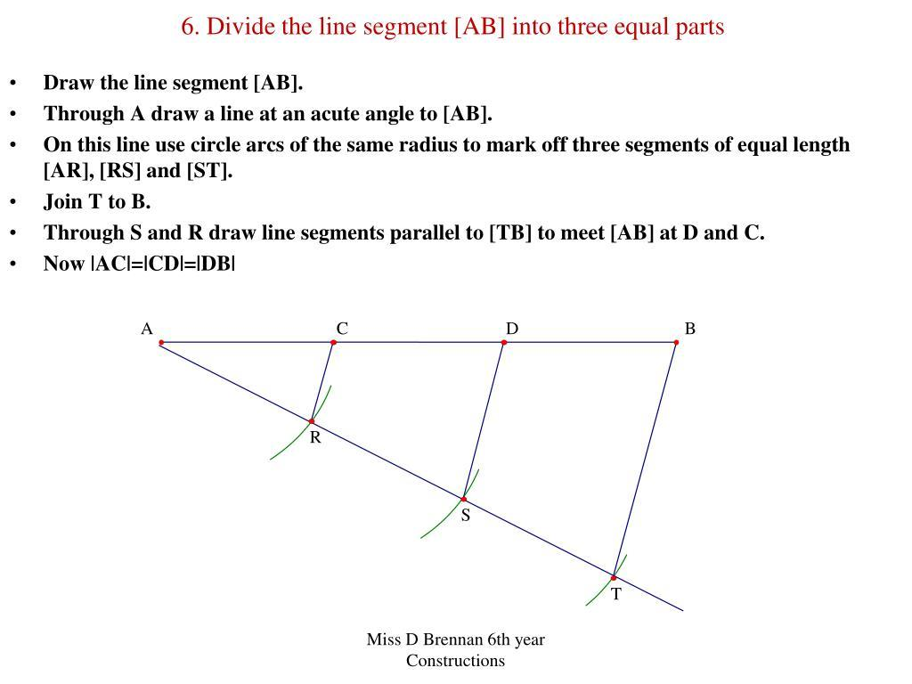
Procedure for Equal Division:
- Draw the given segment $AB$.
- Draw an auxiliary ray from $A$.
- Mark equal intervals along the auxiliary ray using a compass.
- Connect the final marked point to $B$.
- Draw parallel lines through the intermediate marks.
- Identify the intersection points on $AB$.
The resulting segment is divided into equal parts.

Constructing a Perpendicular Line Segment
# Source: AI Source: Provided by: [Data Path: Persons Table -> ID Column: 1, Name_En Column: Motasem Essam] -> From: [ChatGPT] on [7/25/2026]
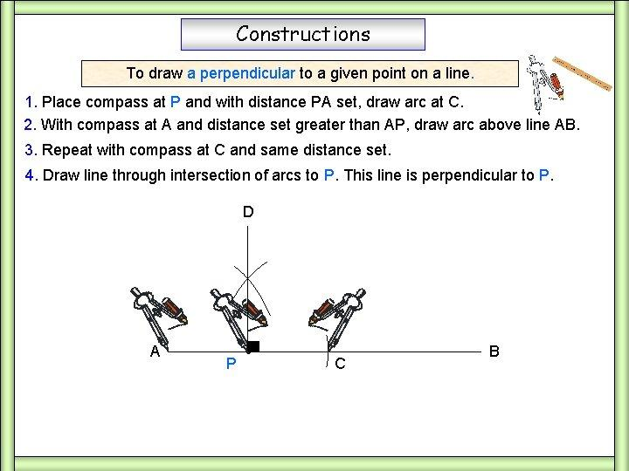
Procedure:
- Draw the reference line segment.
- Mark the point from which the perpendicular segment must be constructed.
- Use a compass to mark two equidistant points on the reference line.
- Construct intersecting arcs from these two points.
- Connect the arc intersection to the required point.
- Mark the resulting perpendicular segment.
The constructed segment forms a right angle with the reference line.

Relationships with Other Geometric Elements
# Source: AI Source: Provided by: [Data Path: Persons Table -> ID Column: 1, Name_En Column: Motasem Essam] -> From: [ChatGPT] on [7/25/2026]
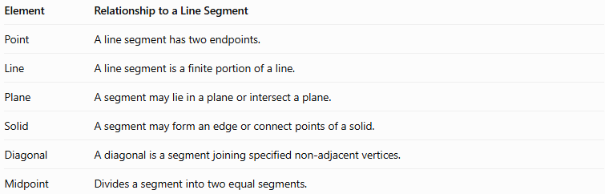
Element | Relationship to a Line Segment
Point | A line segment has two endpoints.
Line | A line segment is a finite portion of a line.
Plane | A segment may lie in a plane or intersect a plane.
Solid | A segment may form an edge or connect points of a solid.
Diagonal | A diagonal is a segment joining specified non-adjacent vertices.
Midpoint | Divides a segment into two equal segments.

Line Segment vs. Line vs. Ray
# Source: AI Source: Provided by: [Data Path: Persons Table -> ID Column: 1, Name_En Column: Motasem Essam] -> From: [ChatGPT] on [7/25/2026]
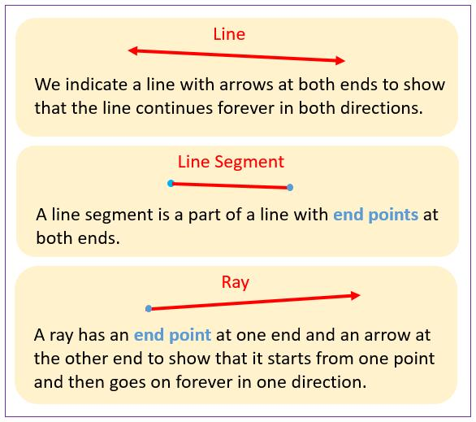
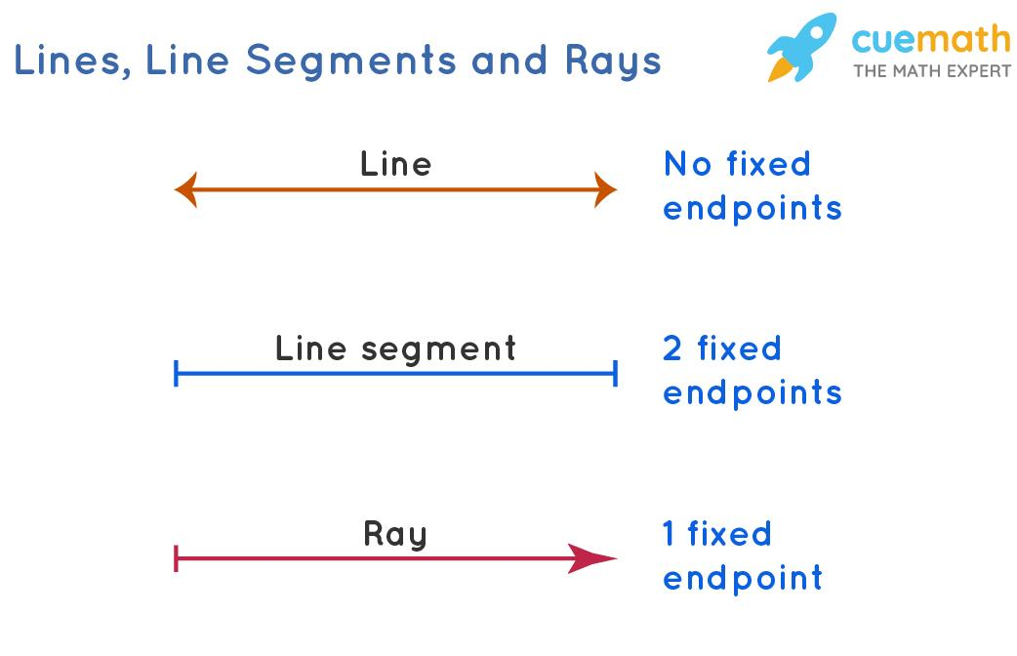
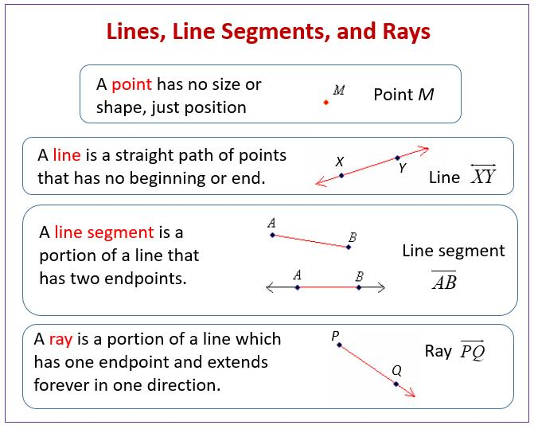
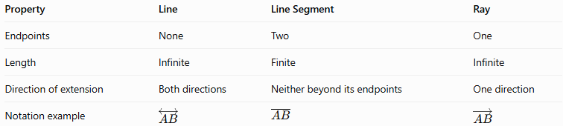
Property | Line | Line Segment | Ray
Endpoints | None | Two | One
Length | Infinite | Finite | Infinite
Direction of extension | Both directions | Neither beyond its endpoints | One direction
Notation example | $$\overset{↔}{AB}$$ | $$\overline{AB}$$ | $$\overset{→}{AB}$$

Applications
# Source: AI Source: Provided by: [Data Path: Persons Table -> ID Column: 1, Name_En Column: Motasem Essam] -> From: [ChatGPT] on [7/25/2026]
Line segments in Solid Geometry are used in:
- Architecture: Measuring edges and distances between structural points.
- Engineering: Defining dimensions and connections between components.
- Computer Graphics: Connecting vertices to build wireframes and 3D models.
- Manufacturing: Measuring lengths and designing solid objects.
- Spatial Geometry: Calculating distances, diagonals, and midpoints.

Key Points
# Source: AI Source: Provided by: [Data Path: Persons Table -> ID Column: 1, Name_En Column: Motasem Essam] -> From: [ChatGPT] on [7/25/2026]
- A line segment is a straight, finite part of a line.
- It has two distinct endpoints and a measurable length.
- The edges of polyhedra are line segments.
- Face diagonals connect non-adjacent vertices on the same face.
- Space diagonals connect vertices that do not lie on the same face.
- The three-dimensional distance formula calculates segment length from coordinates.

Conclusion
# Source: AI Source: Provided by: [Data Path: Persons Table -> ID Column: 1, Name_En Column: Motasem Essam] -> From: [ChatGPT] on [7/25/2026]
A Line Segment in Solid Geometry is a fundamental geometric element that represents a finite, straight distance between two points in three-dimensional space. It is essential for describing the edges of solids, measuring distances, constructing diagonals, and determining midpoints.
Its properties and formulas connect basic geometry with the study of three-dimensional objects, making it useful in architecture, engineering, manufacturing, and computer graphics.

